# CS 340 README Animal Shelter

## Project Two: Animal Shelter

*This application allows a user access to a database of animals in CS 340 Austin Animal Center (AAC) to search and filter the database. The user would search using a filter for animals with Grazioso Salvarethe requester of this project to create a dashboard. Additionally, this project allows a user to benefit from geolocation mapping, user interaction, and charts to locate and utilize animals for search and rescue.*

## Motivation

*This program was designed to test my skill working with databases and manipulating the data within. Python was chosen as the language to drive for mongodb. Python is easily written, manipulated and works well with mongodb. Additionally, Python can be compiled quickly, with a built-in compiler using Jupyter Notebook.*

## Getting Started

*To get this program started you would first,  
1. Enter and Mongo and import the csv file aac_shelter_outvome.csv.*

*2. next one would want to create a simple and a complex index to parse the data stored within the document.*

*3. Now to authenticate a user would want to create both an Admin account and an aacuser account to access the database.*

*4. next a user would need to have access or install python and run the program out of a notebook.*

*5. Finally type in the address of the dash and connect.*

## Installation

*A current version of Python and Jupyter Notebook to run both the .py and the. ipynb files.*

*Access to the PyMongo, Dash, Plotly, Pandas, And Leaflet libraries to create functions in the dash.*

*MongoDB - to access the database.*

## Usage

*Use this space to show useful examples of how your project works and how it can be used. Be sure to include examples of your code, tests, and screenshots.*

### Code Example

Running Dash:  
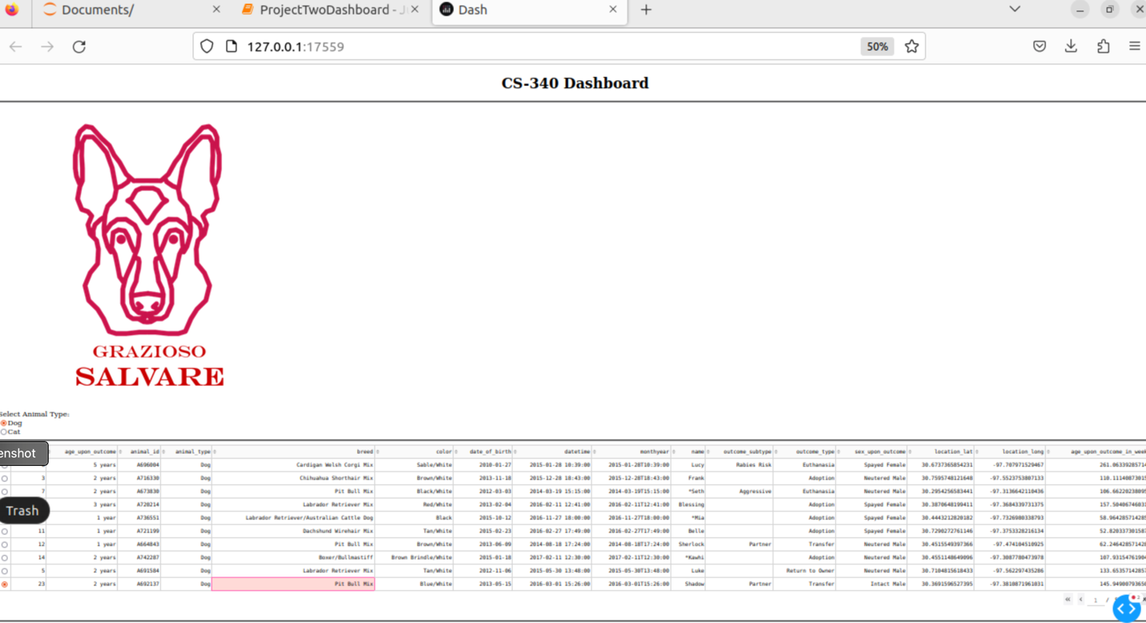

Working Radio buttons:

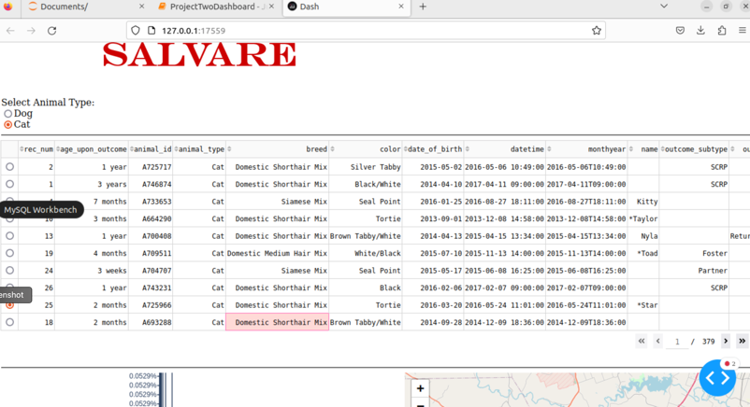

Changing options and switches Geolocation:  
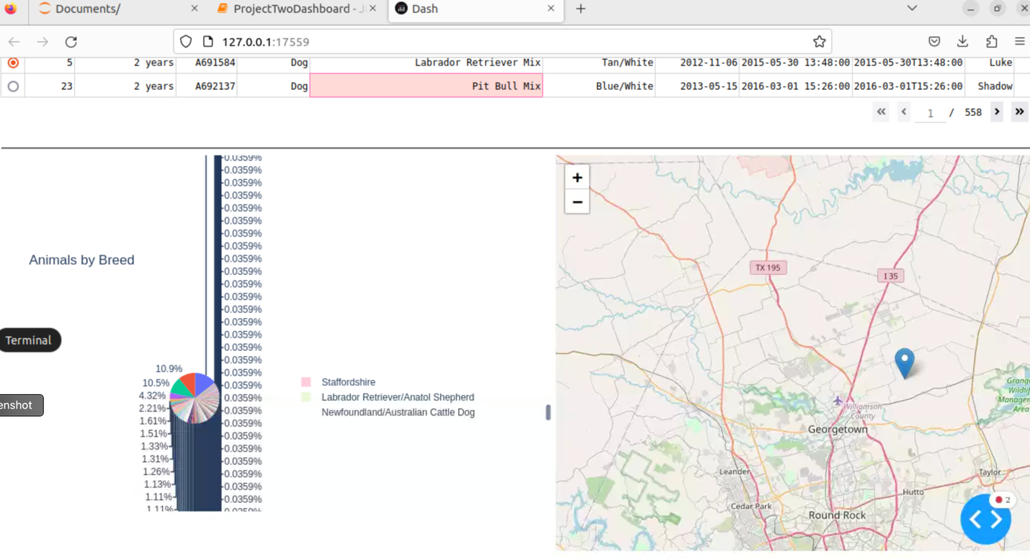

**Errors:**

**The pie chart has too many categories to be an effective display off the data**

## Contact

Your name: Ethan F.